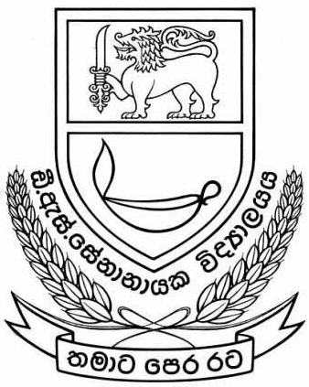

**User’s Manual**

**Staff Management System**

**D.S. Senanayake College, Colombo 7.**

**Prepared By: Students of SLIIT batch of 2013.**

**ITP-14-B1-6**

**1st of October 2014**